Index
Sr no. | topic | Page no
1 | introduction | 3
2 | System requirement | 4
3 | User guide | 5
4 | Source code | 9
5 | graphics | 40
6 | merits | 41
7 | demerits | 41
8 | Further enhancement | 42
9 | conclusion | 42

INTRODUCTION

Now a day every traveling agency manager has need to maintaining customer details. For this purpose, need the software which could easily and conveniently maintain the customer details.
The record of customer can be stored in the single file. This software can be used in several traveling agencies for keeping the records of the customer and also used to add record of school trip, government officer Holiday, family trip and large industries traveling record.
This project “traveling agency” includes some facilities of travel such as registration, search, display, modification, delete etc. This software searches the client data which is store in the record.
The software used for arranging travel services, provide new and improved services, and identify travel related cost savings.

software requirement

Hardware requirements:

Minimum requirements of 64 MB RAM.

Software requirements:

Turbo C
C++
Windows XP

user guide

1) menue
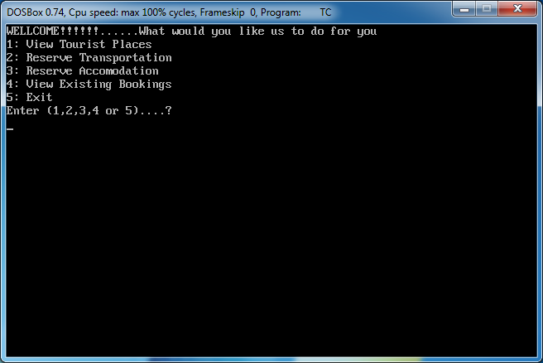
2) to view tourist places
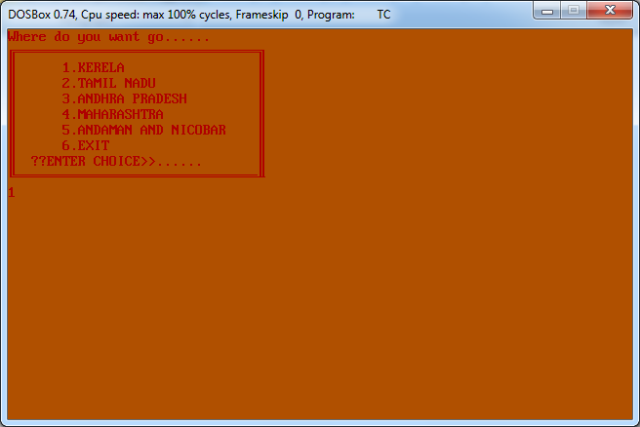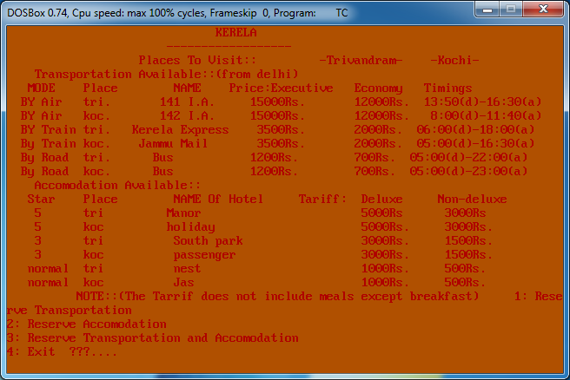

3) reserving transportation

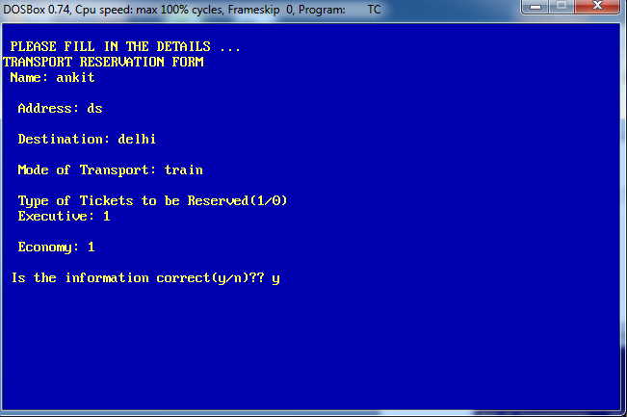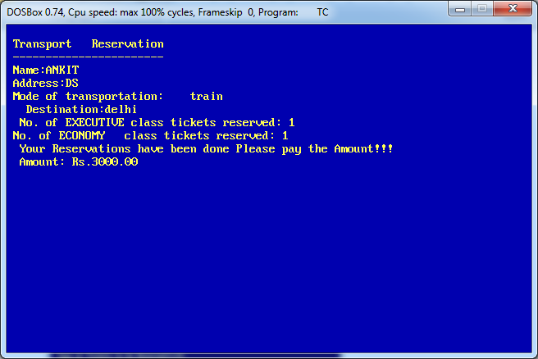
4) reserving hotel

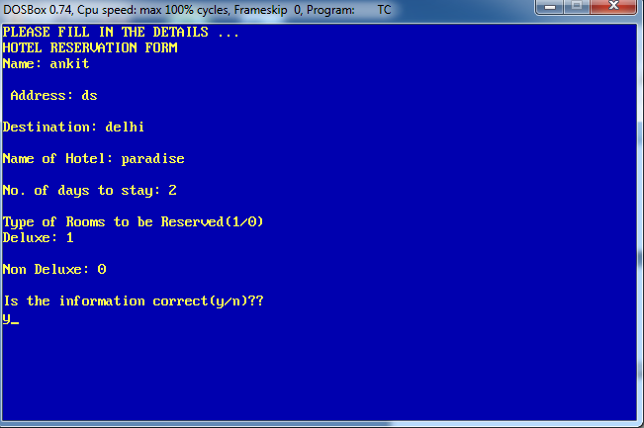
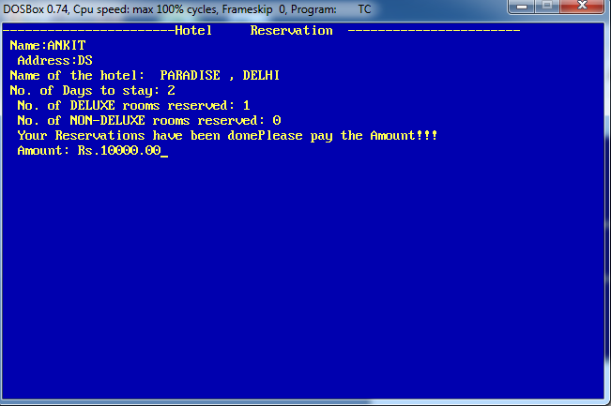
viewing imformation on reservations
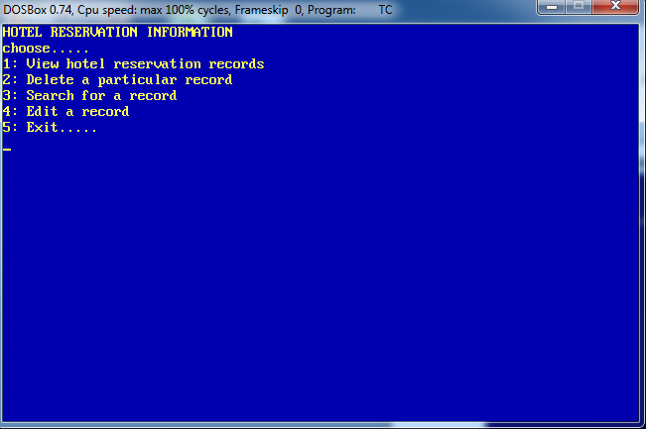
6) searching
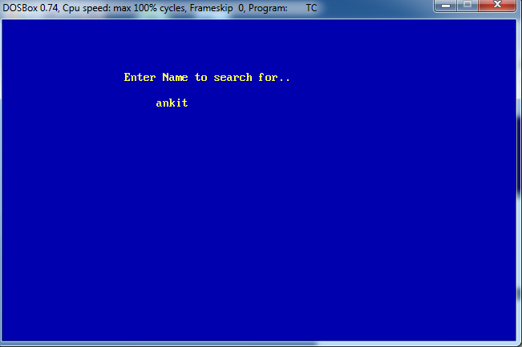

7) editing
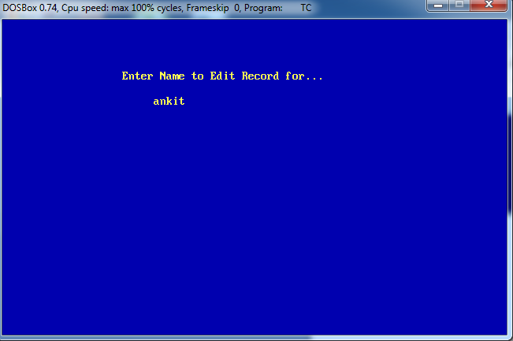

8) deleting

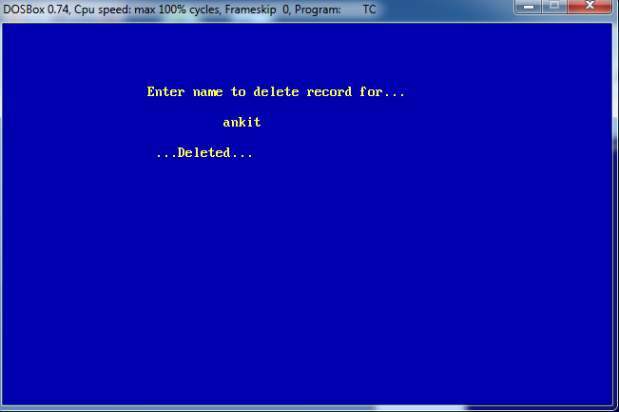

source code

#include<conio.h>
#include<stdio.h>
#include<iomanip.h>
#include<dos.h>
#include<fstream.h>
#include<ctype.h>
#include<string.h>
/********************************************
GLOABAL VARIABLE
**********************************************/
int i=0;

/**********************************************
GLOBAL FUNTIONS
**********************************************/
void startup();
int opening1();
void opening2();
void maketrfile();
void makehofile();
void places();

/**********************************************
CLASS TRAVELAGENCY CONSISTING OF FUNTIONS
AND DATA MEMBERS RELATED TO HOTEL AND
TRANSPORTATION RESERVATIONS.
**********************************************/
class travelagency
{
private:
char name[50],destination[30],hotel[30],add[80],flag1,flag2,trans[30];
float price,price2;
int not1,not2,nor,top,nod,noc,kor1,kor2,top2; //DATA MEMBERS IN PRIVATE AREA
int fst1,fst2,tst1,tst2,nst1,nst2;
int atr1,atr2,ttr1,ttr2,rtr1,rtr2;
public:
int toggle; //DATA MEMBERS IN PUBLIC AREA
void resho();
void showhotel();
void viewhorec();
void showhotelrec();
void delhotelrec(); //MEMBER FUNTIONS FOR HOTEL RESER.
void searchhotrec();
void transferhoteldata();
void edithoteldata();
void transferhoteldata1();
void restr();
void showtransport();
void viewtrrec();
void showtransportrec(); //MEMBER FUNTIONS FOR TRANSPORT RESER.
void deltransportrec();
void searchtransportrec();
void transfertransportdata();
void edittransportdata();
void transfertransportdata1();
void assignprice(); //FUNTION TO CALCULATE PRICE
void nindia(int ndes);
void sindia(int sdes); //FUNTION TO VIEW DIFFERENT DESTINATION
void eindia(int wdes);
void windia(int edes);
void cindia(int cdes);

}user,user1[100]; //GLOBAL CLASS OBJECTS

/*_____________________________________________________________________________________________************************************************************************************/

/**********************************************
CLASS TRAVELAGENCY FUNTIONS DEFINED
OUTSIDE THE CLASS.
**********************************************/

/*_____________________________________________________________________________________________************************************************************************************/
/********************************
HOTEL RESERVATIONS
********************************/
/**********************************************
FUNTION USED TO RESERVE HOTEL.
**********************************************/
void travelagency::resho()
{
clrscr();
flag1='N';
while(flag1!='Y')
{

clrscr();
cout<<"Please Enter Information For Hotel Reservation"<<endl;
cout<<"Please enter the choice of your hotel......"<<endl;
cout<<"1: 5 Star"<<endl;
cout<<"2: 3 Star"<<endl;
cout<<"3: Normal"<<endl;
cout<<"......";cin>>top;
clrscr();

assignprice();
clrscr();
cout<<"PLEASE FILL IN THE DETAILS ..."<<endl;
cout<<"HOTEL RESERVATION FORM"<<endl;
cout<<"Name: ";gets(name); cout<<endl;
cout<<" Address: "; gets(add);cout<<endl;
cout<<"Destination: "; gets(destination);cout<<endl;
cout<<"Name of Hotel: "; gets(hotel); cout<<endl;

cout<<"No. of days to stay: "; cin>>nod; cout<<endl;
cout<<"Type of Rooms to be Reserved(1/0)"; cout<<endl;
cout<<"Deluxe: " ; cin>>kor1;cout<<endl;
cout<<"Non Deluxe: " ; cin>>kor2; cout<<endl;
cout<<"Is the information correct(y/n)?? ";cout<<endl;
cin>>flag1;

flag1=toupper(flag1);
}

showhotel();
}

/**********************************************
FUNTION USED TO SHOW HOTEL RESERVATIONS.
**********************************************/

void travelagency::showhotel()
{
int a,b;

if(top==1)
price=(fst1*kor1*nod)+(fst2*kor2*nod);
else
if(top==2)
price=(tst1*kor1*nod)+(tst2*kor2*nod);
else
if(top==3)
price=(nst1*kor1*nod)+(nst2*kor2*nod);

if(toggle==1)
{
clrscr();

for(int h=25;h<50;h++)
{
gotoxy(20,8);cout<<"Please wait while we make the Reservation";
gotoxy(h,10);cout<<"Û";
delay(130);
}
toggle=0;
}
clrscr();
cout<<"-----------------------Hotel Reservation ";
cout<<"-----------------------";
cout<<" \n Name:"<<strupr(name);
cout<<" \n Address:"<<strupr(add);
cout<<" \n Name of the hotel: "<<strupr(hotel)
<<" , "<<strupr(destination);
cout<<" \n No. of Days to stay: "<<nod;
cout<<" \n No. of DELUXE rooms reserved: "<<kor1;
cout<<" \n No. of NON-DELUXE rooms reserved: "<<kor2;
cout<<" \n Your Reservations have been done"
"Please pay the Amount!!!";
cout<<" \n Amount: Rs."<<setprecision(2)<<price;
getch();

}

/**********************************************
FUNTION USED TO VIEW HOTEL RECORDS.
**********************************************/
void travelagency::viewhorec()
{

int option;

while(option!=5)
{
clrscr();
cout<<"HOTEL RESERVATION INFORMATION"<<endl;
cout<<"choose....."<<endl;;
cout<<"1: View hotel reservation records"<<endl;;
cout<<"2: Delete a particular record"<<endl;;
cout<<"3: Search for a record"<<endl;;
cout<<"4: Edit a record "<<endl;;
cout<<"5: Exit..... "<<endl;;
cin>>option;
switch(option)
{
case 1:showhotelrec();
break;
case 2:delhotelrec();
break;
case 3:searchhotrec();
break;
case 4:edithoteldata();
break;
}
}
}

/**********************************************
FUNTION USED TO SHOW ALL HOTEL RESERVATIONS.
**********************************************/
void travelagency::showhotelrec()
{

fstream fil1;

fil1.open("hotel.dat",ios::binary|ios::in);

while(fil1.read((char*)&user,sizeof (user)))
user.showhotel();

fil1.close();
}

/**********************************************
FUNTION USED TO DELETE A HOTEL RECORD.
**********************************************/
void travelagency::delhotelrec()
{
clrscr();

char dname[20];
gotoxy(20,5);cout<<"Enter name to delete record for...";
gotoxy(30,7);gets(dname);
strupr(dname);

fstream fil2,fil3;
int del=0;

fil2.open("hotel.dat",ios::binary | ios::in);
fil3.open("temp.dat",ios::binary | ios::out);

while(fil2.read ((char*)&user,sizeof (user)))
{
if ((strcmp(name,dname))!=0)
fil3.write((char*)&user,sizeof (user));
else
del++;
}
if(del!=0)
cout<<endl<<" ...Deleted...";
else
cout<<endl<<" Record not found..";
getch();
fil2.close();
fil3.close();

transferhoteldata();
}

/**********************************************
FUNTION USED TO TRANSFER UNDELETED HOTEL RECORDS.
**********************************************/
void travelagency::transferhoteldata()
{

fstream oldfile,newfile;

oldfile.open("temp.dat",ios::binary | ios::in);
newfile.open("hotel.dat",ios::binary | ios::out);

while(oldfile.read((char*)&user,sizeof(user)))
newfile.write((char*)&user,sizeof (user));

oldfile.close();
newfile.close();
}

/**********************************************
FUNTION USED TO SEARCH FOR A HOTEL RECORD.
**********************************************/
void travelagency::searchhotrec()
{
clrscr();

char sname[20];
gotoxy(20,5);cout<<"Enter Name to search for..";
gotoxy(25,7);gets(sname);
strupr(sname);

fstream fil4;
fil4.open("hotel.dat",ios::binary | ios::in);

int srch=0;

while(fil4.read((char*)&user,sizeof (user)))
{
if(strcmp(name,sname)==0)
{
srch++;
user.showhotel();
}
}
if(srch==0)
cout<<" No Record Exists";
fil4.close();
getch();
}

/**********************************************
FUNTION USED TO EDIT A HOTEL RECORD.
**********************************************/
void travelagency::edithoteldata()
{
clrscr();
char ename[30];int ede=0;
gotoxy(20,5);cout<<"Enter Name to Edit Record for...";
gotoxy(25,7);gets(ename);
strupr(ename);

fstream fil5,fil6;
fil5.open("hotel.dat",ios::binary | ios::in) ;
fil6.open("temp1.dat",ios::binary | ios::out ) ;

while(fil5.read((char*)&user,sizeof(user)))
{
if (strcmp (ename,name)==0)
{
resho();
ede++;
}
fil6.write((char*)&user,sizeof (user));
}
if(ede==0)
{
gotoxy(25,17);cout<<"RECORD DOESNT EXIST!!!!";
}
getch();
fil5.close();
fil6.close();
transferhoteldata1(); //TO TRANSFER EDITED HOTEL RECORD
}
/**********************************************
FUNTION USED TO TRANSFER EDITED HOTEL RECORDS.
**********************************************/
void travelagency::transferhoteldata1()
{
fstream oldfile2,newfile2;

oldfile2.open("temp1.dat",ios::binary | ios::in);
newfile2.open("hotel.dat",ios::binary | ios::out);

while(oldfile2.read((char*)&user,sizeof(user)))
newfile2.write((char*)&user,sizeof (user));

oldfile2.close();
newfile2.close();
}

/*_____________________________________________________________________________________________************************************************************************************/

/********************************
TRANSPORTATION RESERVATIONS
********************************/

/**********************************************
FUNTION USED TO RESERVE TRANSPORTATION.
**********************************************/
void travelagency::restr()
{
clrscr();
flag2='N';
while(flag2!='Y')
{
clrscr();
cout<<"\n Please Enter Information For Transport Reservation";
cout<<" \nPlease enter the choice of your mode of transportaion......";
cout<<"\n 1: by Air";
cout<<"\n 2: by Train";
cout<<"\n 3: by Road"<<endl;
cout<<"\n ......";cin>>top2;
clrscr();

assignprice();
clrscr();
cout<<"\n PLEASE FILL IN THE DETAILS ...";
cout<<"\nTRANSPORT RESERVATION FORM";
cout<<"\n Name: ";gets(name);
cout<<"\n Address: "; gets(add);
cout<<"\n Destination: ";gets(destination);
cout<<"\n Mode of Transport: ";gets(trans);
cout<<"\n Type of Tickets to be Reserved(1/0)" ;
cout<<"\n Executive: "; cin>>not2;
cout<<"\n Economy: "; cin>>not2;
cout<<"\n Is the information correct(y/n)?? ";
cin>>flag2;
flag2=toupper(flag2);
}
showtransport();
}

/**********************************************
FUNTION USED TO SHOW TRANSPORT RESERVATION.
**********************************************/
void travelagency::showtransport()
{
if(top2==1)
price2=(atr1*not1)+(atr2*not2);
else
if(top2==2)
price2=(ttr1*not1)+(ttr2*not2);
else
if(top2==3)
price2=(rtr1*not1)+(rtr2*not2);

if(toggle==1)
{
clrscr();
for(int h=25;h<50;h++)
{
gotoxy(20,8);cout<<"Please wait while we make the Reservation";
gotoxy(h,10);cout<<"Û";
delay(250);
}
toggle=0;
}
clrscr();
cout<<"\n Transport Reservation ";
cout<<"\n -----------------------";
cout<<"\n Name:"<<strupr(name);
cout<<"\n Address:"<<strupr(add);
cout<<"\n Mode of transportation: "<<trans
<<"\n Destination:"<<destination;
cout<<"\n No. of EXECUTIVE class tickets reserved: "<<not1;
cout<<" \n No. of ECONOMY class tickets reserved: "<<not2;
cout<<"\n Your Reservations have been done Please pay the Amount!!!";
cout<<n Amount: Rs."<<setprecision(2)<<price2;
getch(0;
}
**********************************************
FUNTION USED TO VIEW TRANSPORT RECORDS.
**********************************************/
void travelagency::viewtrrec()
{
int option;
while(option!=5)
{
clrscr();
cout<<"\n TRANSPORT RESERVATION INFORMATION...";
cout<<"\n choose.....";
cout<<"\n 1: View transport reservation records";
cout<<"\n 2: Delete a particular record";
cout<<"\n 3: Search for a record";
cout<<"\n 4: Edit a record ";
cout<<"\n 5: Exit... ";
cin>>option;
switch(option)
{
case 1:showtransportrec();
break;
case 2:deltransportrec();
break;
case 3:searchtransportrec();
break;
case 4:edittransportdata();
break;
}
}
}
/**********************************************
FUNTION USED TO SHOW ALL TRANSPORT RECORDS.
**********************************************/
void travelagency::showtransportrec()
{
fstream file1;
file1.open("transport.dat",ios::binary|ios::in);
while(file1.read((char*)&user,sizeof (user)))
user.showtransport();
file1.close();
}
/**********************************************
FUNTION USED TO DELETE A TRANSPORT RECORDS.
**********************************************/
void travelagency::deltransportrec()
{
clrscr();
char delname[20];
gotoxy(20,5);cout<<"Enter name to delete record for...";
gotoxy(30,7);gets(delname);
strupr(delname);
fstream file2,file3;
int dele=0;
file2.open("transport.dat",ios::binary | ios::in);
file3.open("temp3.dat",ios::binary | ios::out );
while(file2.read ((char*)&user,sizeof (user)))
{
if ((strcmp(name,delname))!=0)
file3.write((char*)&user,sizeof (user));
else
dele++;
}
if(dele!=0)
cout<<endl<<" ...Deleted...";
else
cout<<endl<<" Record not found..";
getch();
file2.close();
file3.close();
transfertransportdata();
}

/**********************************************
FUNTION USED TO TRANSFER UNDELETED TRANSPORT RECORDS.
**********************************************/
void travelagency::transfertransportdata()
{
fstream oldfile1,newfile1;
oldfile1.open("temp3.dat",ios::binary | ios::in);
newfile1.open("transport.dat",ios::binary | ios::out);
while(oldfile1.read((char*)&user,sizeof(user)))
newfile1.write((char*)&user,sizeof (user));
oldfile1.close();
newfile1.close();
}
/**********************************************
FUNTION USED TO SEARCH FOR A TRANSPORT RECORDS.
**********************************************/
void travelagency::searchtransportrec()
{
clrscr();
char sename[20];
gotoxy(20,5);cout<<"Enter Name to search for..";
gotoxy(25,7);gets(sename);
strupr(sename);
fstream file4;
file4.open("transport.dat",ios::binary | ios::in);
int serch=0;
while(file4.read((char*)&user,sizeof (user)))
{
if(strcmp(name,sename)==0)
{
serch++;
user.showtransport();
}
}
if(serch==0)
cout<<" No Record Exists";
file4.close();
getch();
}
/**********************************************
FUNTION USED TO EDIT TRANSPORT RECORD.
**********************************************/
void travelagency::edittransportdata()
{
clrscr();
char edname[30];
int ede1=0;
gotoxy(20,5);cout<<"Enter Name to Edit Record for...";
gotoxy(25,7);gets(edname);
strupr(edname);
fstream file5,file6;
file5.open("transport.dat",ios::binary | ios::in) ;
file6.open("temp2.dat",ios::binary | ios::out ) ;
while(file5.read((char*)&user,sizeof(user)))
{
if (strcmp (edname,name)==0)
{
restr();
ede1++;
}
file6.write((char*)&user,sizeof (user));
}
if(ede1==0)
{
gotoxy(25,17);cout<<"RECORD DOESNT EXIST!!!!";
}
getch();
file5.close();
file6.close();

transfertransportdata1(); //TO TRANSFER EDITED TRANSPORT RECORD
}

/**********************************************
FUNTION USED TO TRASFER EDITED TRANSPORT RECORDS.
**********************************************/
void travelagency::transfertransportdata1()
{
fstream oldfile3,newfile3;
oldfile3.open("temp2.dat",ios::binary | ios::in);
newfile3.open("transport.dat",ios::binary | ios::out);
while(oldfile3.read((char*)&user,sizeof(user)))
newfile3.write((char*)&user,sizeof (user));
oldfile3.close();
newfile3.close();
}
/*_____________________________________________________________________________________________************************************************************************************/

/**********************************************
MAIN FUNTION
USED TO CALL OTHER FUNTIONS
**********************************************/

/*_____________________________________________________________________________________________************************************************************************************/

void main()
{
clrscr();
cout.setf(ios::fixed,ios::floatfield);
cout.setf(ios::showpoint);
startup(); //FUNTION TO DISPLAY INTRODUCTION SCREEN
int opt;
while(opt!=5)
{
opt=opening1(); //FUNTION CALL TO DISPLAY MENU
switch(opt)
{
case 1:places(); //FUNTION CALL TO VIEW PLACES
break;
case 2: //FUNTION CALL TO RESERVE TRANSPORT
maketrfile();i++;
break;
case 3: //FUNTION CALL TO RESERVE HOTEL
makehofile();i++;
break;
case 4:clrscr();
int search1;
cout<<"Enter 1 or 2"<<endl;
cout<<"1: Hotel Reservation Records"<<endl;
cout<<"2: Transport Reservation Records"<<endl;
cout<<"??....."<<endl;cin>>search1;

switch(search1)
{
case 1:user.viewhorec(); //FUNTION CALL FOR HOTEL RECORDS
break;
case 2:user.viewtrrec(); //FUNTION CALL FOR TRANSPORT RECORDS
break;
}
break;
}
}
}
/**********************************************
FUNTION USED TO MAKE TRANSPORT RECORD.
**********************************************/
void maketrfile()
{
fstream fil;
fil.open("transport.dat",ios::binary | ios::out |ios::app);
user1[i].toggle=1;
user1[i].restr();
fil.write((char*)&user1[i],sizeof (user1[i]));
fil.close();
}
/**********************************************
FUNTION USED TO MAKE HOTEL RECORD.
**********************************************/
void makehofile()
{
fstream fil;
fil.open("hotel.dat",ios::binary | ios::out |ios::app );
user1[i].toggle=1;
user1[i].resho();
fil.write((char*)&user1[i],sizeof (user1[i]));
fil.close();
}
/**********************************************
FUNTION USED TO DISPLAY INTRODUCTION SCREEN
**********************************************/
void startup()
{

{
clrscr();

;cout<<"Welcome to the AJ TRAVEL AGENCY"<<endl;
cout<<" ANKIT JOSHI Presents .... "<<endl;
delay(7000);

cout<<"travel india"<<endl;
delay(5000);

cout<<"Please Wait"<<endl;

delay(2000);
cout<<"press any key to continue";
}

getch();
}
/**********************************************
FUNTION USED TO DISPLAY MENU.
**********************************************/
int opening1()
{
int pass;
clrscr();

cout<<"WELLCOME!!!!!!......"
"What would you like us to do for you"<<endl;
cout<<"1: View Tourist Places"<<endl;
cout<<"2: Reserve Transportation"<<endl;
cout<<"3: Reserve Accomodation"<<endl;
cout<<"4: View Existing Bookings"<<endl;
cout<<"5: Exit"<<endl;
cout<<"Enter (1,2,3,4 or 5)....? "<<endl;
delay(100);
cin>>pass;
return(pass);
}
void opening2() //function to display menu with places
{
int opt2;
cout<<"1: Reserve Transportation"<<endl;
cout<<"2: Reserve Accomodation"<<endl;
cout<<"3: Reserve Transportation and Accomodation"<<endl;
cout<<"4: Exit ???.... ";cin>>opt2; cout<<endl;
if (opt2!=4)
{
switch(opt2)
{
case 1:maketrfile();i++;
break;
case 2:makehofile();i++;
break;
case 3:maketrfile();i++;
makehofile();i++;
break;
}
}
}

/**********************************************
FUNTION USED TO DISPLAY CHOICE OF DESTINATION.
**********************************************/
void places()
{
int des;
for(int j=0;j<20;j++)
{
clrscr();
cout<<"Choose Destination"<<endl;
cout<<"ÉÍÍÍÍÍÍÍÍÍÍÍÍÍÍÍÍÍÍÍÍÍÍÍÍÍÍÍÍÍÍÍ» "<<endl;
cout<<"º 1.NORTH INDIA º "<<endl;
cout<<"º 2.SOUTH INDIA º "<<endl;
cout<<"º 3.EAST INDIA º "<<endl;
cout<<"º 4.WEST INDIA º "<<endl;
cout<<"º 5.CENTRAL INDIA º "<<endl;
cout<<"º 6.EXIT º "<<endl;
cout<<"º ??ENTER CHOICE>>.....? º "<<endl;
cout<<"ÈÍÍÍÍÍÍÍÍÍÍÍÍÍÍÍÍÍÍÍÍÍÍÍÍÍÍÍÍÍÍÍÐ "<<endl;
delay(50);
}
cin>>des;
int des1;
if (des!=6)
{
switch(des)
{
case 1: for(j=0;j<20;j++)
{
clrscr();
cout<<"Where do you want go......";
cout<<"ÉÍÍÍÍÍÍÍÍÍÍÍÍÍÍÍÍÍÍÍÍÍÍÍÍÍÍÍÍÍÍÍ» "<<endl;
cout<<"º 1.JAMMU & KASHMIR º "<<endl;
cout<<"º 2.HARYANA º "<<endl;
cout<<"º 3.PUNJAB º "<<endl;
cout<<"º 4.HIMACHAL PRADESH º "<<endl;
cout<<"º 5.EXIT º "<<endl;
cout<<"º º "<<endl;
cout<<"º ??ENTER CHOICE>>...... º "<<endl;
cout<<"ÈÍÍÍÍÍÍÍÍÍÍÍÍÍÍÍÍÍÍÍÍÍÍÍÍÍÍÍÍÍÍÍÐ "<<endl;
delay(50);
}
cin>>des1;
if(des1!=5)
user.nindia(des1);
break;

case 2: for(j=0;j<20;j++)
{
clrscr();
cout<<"Where do you want go......"<<endl;
cout<<"ÉÍÍÍÍÍÍÍÍÍÍÍÍÍÍÍÍÍÍÍÍÍÍÍÍÍÍÍÍÍÍÍ» "<<endl;
cout<<"º 1.KERELA º "<<endl;
cout<<"º 2.TAMIL NADU º"<<endl;
cout<<"º 3.ANDHRA PRADESH º "<<endl;
cout<<"º 4.MAHARASHTRA º "<<endl;
cout<<"º 5.ANDAMAN AND NICOBAR º "<<endl;
cout<<"º 6.EXIT º "<<endl;
cout<<"º ??ENTER CHOICE>>...... º "<<endl;
cout<<"ÈÍÍÍÍÍÍÍÍÍÍÍÍÍÍÍÍÍÍÍÍÍÍÍÍÍÍÍÍÍÍÍÐ "<<endl;
delay(50);
}
cin>>des1;
if(des1!=6)
user.sindia(des1);
break;
case 3: for(j=0;j<20;j++)
{
clrscr();
cout<<"Where do you want go......"<<endl;
cout<<"ÉÍÍÍÍÍÍÍÍÍÍÍÍÍÍÍÍÍÍÍÍÍÍÍÍÍÍÍÍÍÍÍ» "<<endl;
cout<<"º 1.ASSAM º "<<endl;
cout<<"º 2.ARUNACHAL PRADESH º"<<endl;
cout<<"º 3.BIHAR º "<<endl;
cout<<"º 4.WEST BENGAL º "<<endl;
cout<<"º 5.UTTAR PRADESH º "<<endl;
cout<<"º 6.EXIT º "<<endl;
cout<<"º ??ENTER CHOICE>>...... º "<<endl;
cout<<"ÈÍÍÍÍÍÍÍÍÍÍÍÍÍÍÍÍÍÍÍÍÍÍÍÍÍÍÍÍÍÍÍÐ "<<endl;
delay(50);
}
;cin>>des1;
if(des1!=6)
user.eindia(des1);
break;
case 4: for(j=0;j<20;j++)
{
clrscr();
cout<<"Where do you want go......"<<endl;
cout<<"ÉÍÍÍÍÍÍÍÍÍÍÍÍÍÍÍÍÍÍÍÍÍÍÍÍÍÍÍÍÍÍÍ» "<<endl;
cout<<"º º "<<endl;
cout<<"º 1.GUJARAT º"<<endl;
cout<<"º 2.RAJASTHAN º "<<endl;
cout<<"º 3.EXIT º "<<endl;
cout<<"º º "<<endl;
cout<<"º º "<<endl;
cout<<"º ??ENTER CHOICE>>...... º "<<endl;
cout<<"ÈÍÍÍÍÍÍÍÍÍÍÍÍÍÍÍÍÍÍÍÍÍÍÍÍÍÍÍÍÍÍÍÐ "<<endl;
delay(50);
}
cin>>des1;
if(des1!=3)
user.windia(des1);
break;

case 5: for(j=0;j<20;j++)
{
clrscr();
cout<<"Where do you want go......"<<endl;
cout<<"ÉÍÍÍÍÍÍÍÍÍÍÍÍÍÍÍÍÍÍÍÍÍÍÍÍÍÍÍÍÍÍÍ» "<<endl;
cout<<"º º "<<endl;
cout<<"º º"<<endl;
cout<<"º 1.ORISSA º "<<endl;
cout<<"º 2.MADHYA PRADESH º "<<endl;
cout<<"º 3.EXIT º "<<endl;
cout<<"º º "<<endl;
cout<<"º ??ENTER CHOICE>>...... º "<<endl;
cout<<"ÈÍÍÍÍÍÍÍÍÍÍÍÍÍÍÍÍÍÍÍÍÍÍÍÍÍÍÍÍÍÍÍÐ "<<endl;
delay(50);
}
cin>>des1;
if(des1!=3)
user.cindia(des1);
break;
}
}
}
/**********************************************
FUNTION USED TO DISPLAY NORTH-INDIA INFORMATION.
**********************************************/
void travelagency::nindia(int ndes)
{
switch(ndes)
{
case 1:clrscr();
textcolor(RED);
textbackground(YELLOW);
gotoxy(25,1);cout<<"Jammu and Kashmir ";
gotoxy(24,2);cout<<"------------------";
gotoxy(20,3);cout<<"Places To Visit:: -Kashmir- -Jammu- "<<"\n";
gotoxy(5,4);cout<<"Transportation Available::(from delhi)"<<"\n";
cout<<" MODE Place NAME Price:Executive Economy Timings "<<"\n";
cout<<" BY Air kash. 041 I.A. 12000Rs. 9000Rs. 13:50(d)-15:30(a)"<<"\n";
cout<<" BY Air jam. 042 I.A. 12000Rs. 9000Rs. 8:00(d)- 9:40(a)"<<"\n"; cout<<" BY Train kash. Kashmir Express 2500Rs. 2000Rs. 13:00(d)-18:00(a)"<<endl;
cout<<" By Train jam. Jammu Mail 2500Rs. 2000Rs. 15:00(d)-16:30(a)"<<"\n";
cout<<" By Road kash. Bus 700Rs. 500Rs. 12:00(d)-20:00(a)"<<"\n";
cout<<" By Road jam. Bus 700Rs. 500Rs. 14:00(d)-15:00(a)"<<"\n";
gotoxy(5,12);cout<<"Accomodation Available::"<<endl;
cout<<" Star Place NAME Of Hotel Tariff: Deluxe Non-deluxe "<<"\n";
cout<<" 5 kash Kashmir 5000Rs 3000Rs "<<"\n";
cout<<" 5 jam holiday 5000Rs. 3000Rs. "<<"\n"; cout<<" 3 kash queen 3000Rs. 1500Rs. "<<endl;
cout<<" 3 jam passenger 3000Rs. 1500Rs. "<<"\n";
cout<<" normal kash rest 1000Rs. 500Rs. "<<endl;
cout<<" normal jam guest 1000Rs. 500Rs. "<<endl;
cout<<setw(10)<<" NOTE::(The Tarrif does not include meals except breakfast) ";

atr1=12000;atr2=9000;ttr1=2500;ttr2=2000;rtr1=700;rtr2=500;
fst1=5000;fst2=3000;tst1=3000;tst2=1500;nst1=1000;nst2=500;
opening2();
break;
case 2:clrscr();
textcolor(RED);
textbackground(YELLOW);
gotoxy(25,1);cout<<" HARYANA";
gotoxy(24,2);cout<<"------------------";
gotoxy(20,3);cout<<"Places To Visit:: -Chandigarh- -Gurgaon- "<<endl;
gotoxy(5,4);cout<<"Transportation Available::(from delhi)"<<endl;
cout<<" MODE Place NAME Price:Executive Economy Timings "<<endl;
cout<<" BY Air chan. 051 I.A. 10000Rs. 8000Rs. 12:50(d)-13:30(a)"<<endl;
cout<<" BY Air chan. 052 I.A. 10000Rs. 8000Rs. 7:00(d)- 7:40(a)"<<endl;
cout<<" BY Train chan. Haryana Express 1500Rs. 1000Rs. 13:00(d)-18:00(a)"<<endl;
cout<<" By Train gur. Punjab Mail 1500Rs. 1000Rs. 14:00(d)-14:30(a)"<<endl;
cout<<" By Road chan. Bus 300Rs. 200Rs. 12:00(d)-20:00(a)"<<endl;
cout<<" By Road gur. Bus 300Rs. 200Rs. 14:00(d)-15:00(a)"<<endl;
gotoxy(5,12);cout<<"Accomodation Available::"<<endl;
cout<<" Star Place NAME Of Hotel Tariff: Deluxe Non-deluxe "<<endl;
cout<<" 5 chan taj 5000Rs 3000Rs "<<endl;
cout<<" 5 gur broadway 5000Rs. 3000Rs. "<<endl;
cout<<" 3 chan king 3000Rs. 1500Rs. "<<endl;
cout<<" 3 gur resort 3000Rs. 1500Rs. "<<endl;
cout<<" normal chan sarai 1000Rs. 500Rs. "<<endl;
cout<<" normal gur star 1000Rs. 500Rs. "<<endl;
cout<<setw(10)<<" NOTE::(The Tarrif does not include meals except breakfast) ";
atr1=10000;atr2=8000;ttr1=1500;ttr2=1000;rtr1=300;rtr2=200;
fst1=5000;fst2=3000;tst1=3000;tst2=1500;nst1=1000;nst2=500;
opening2();
break;

case 3:clrscr();
textcolor(RED);
textbackground(YELLOW);
gotoxy(25,1);cout<<" PUNJAB";
gotoxy(24,2);cout<<"------------------";
gotoxy(20,3);cout<<"Places To Visit:: -Amritsar- -Ludhiana- "<<endl;
gotoxy(5,4);cout<<"Transportation Available::(from delhi)"<<endl;
cout<<" MODE Place NAME Price:Executive Economy Timings "<<endl;
cout<<" BY Air amr. 051 I.A. 8000Rs. 6000Rs. 12:50(d)-13:30(a)"<<endl;
cout<<" BY Air lud. 052 I.A. 8000Rs. 6000Rs. 5:00(d)- 5:40(a)"<<endl;
cout<<" BY Train amr. Haryana Express 1200Rs. 1000Rs. 13:00(d)-18:00(a)"<<endl;
cout<<" By Train lud. Punjab Mail 1200Rs. 1000Rs. 14:00(d)-14:30(a)"<<endl;
cout<<" By Road amr. Bus 300Rs. 200Rs. 12:00(d)-20:00(a)"<<endl;
cout<<" By Road lud. Bus 300Rs. 200Rs. 14:00(d)-15:00(a)"<<endl;
gotoxy(5,12);cout<<"Accomodation Available::"<<endl;
cout<<" Star Place NAME Of Hotel Tariff: Deluxe Non-deluxe "<<endl;
cout<<" 5 amr Nanda 5000Rs 3000Rs "<<endl;
cout<<" 5 lud Shiraz 5000Rs. 3000Rs. "<<endl;
cout<<" 3 amr Amaitas 3000Rs. 1500Rs. "<<endl;
cout<<" 3 lud Gulmor 3000Rs. 1500Rs. "<<endl;
cout<<" normal amr salam 1000Rs. 500Rs. "<<endl;
cout<<" normal lud stars 1000Rs. 500Rs. "<<endl;
cout<<setw(10)<<" NOTE::(The Tarrif does not include meals except breakfast) ";
atr1=8000;atr2=6000;ttr1=1200;ttr2=1000;rtr1=300;rtr2=200;
fst1=5000;fst2=3000;tst1=3000;tst2=1500;nst1=1000;nst2=500;
opening2();
break;
case 4:clrscr();
textcolor(YELLOW);
textbackground(BLUE);
gotoxy(25,1);cout<<" HIMACHAL PRADESH";
gotoxy(24,2);cout<<"------------------";
gotoxy(20,3);cout<<"Places To Visit:: -Shimla- -Manali- "<<endl;
gotoxy(5,4);cout<<"Transportation Available::(from delhi)"<<endl;
cout<<" MODE Place NAME Price:Executive Economy Timings "<<endl;
cout<<" BY Air shi. 151 I.A. 10000Rs. 8000Rs. 12:30(d)-13:30(a)"<<endl;
cout<<" BY Air man. 152 I.A. 10000Rs. 8000Rs. 6:50(d)- 7:40(a)"<<endl;
cout<<" BY Train shi. Himachal Express 2000Rs. 1000Rs. 13:00(d)-19:00(a)"<<endl;
cout<<" By Train man. kalka Mail 2000Rs. 1000Rs. 14:00(d)-19:30(a)"<<endl;
cout<<" By Road shi. Bus 800Rs. 500Rs. 12:00(d)-20:00(a)"<<endl;
cout<<" By Road man. Bus 800Rs. 500Rs. 14:00(d)-20:00(a)"<<endl;
gotoxy(5,12);cout<<"Accomodation Available::"<<endl;
cout<<" Star Place NAME Of Hotel Tariff: Deluxe Non-deluxe "<<endl;
cout<<" 5 shi chamba 4000Rs 3000Rs "<<endl;
cout<<" 5 man chanakya 4000Rs. 3000Rs. "<<endl;
cout<<" 3 shi geetanjali 3000Rs. 1500Rs. "<<endl;
cout<<" 3 man parkview 3000Rs. 1500Rs. "<<endl;
cout<<" normal shi guesthouse 800Rs. 500Rs. "<<endl;
cout<<" normal man mountview 800Rs. 500Rs. "<<endl;
cout<<setw(10)<<" NOTE::(The Tarrif does not include meals except breakfast) ";
atr1=10000;atr2=8000;ttr1=2000;ttr2=1000;rtr1=800;rtr2=500;
fst1=4000;fst2=3000;tst1=3000;tst2=1500;nst1=800;nst2=500;
opening2();
break;
}
}
/**********************************************
FUNTION USED TO DISPLAY SOUTH-INDIA INFORMATION.
**********************************************/
void travelagency::sindia(int sdes)
{
switch(sdes)
{
case 1:clrscr();
textcolor(RED);
textbackground(YELLOW);
gotoxy(25,1);cout<<" KERELA ";
gotoxy(24,2);cout<<"------------------";
gotoxy(20,3);cout<<"Places To Visit:: -Trivandram- -Kochi- "<<endl;
gotoxy(5,4);cout<<"Transportation Available::(from delhi)"<<endl;
cout<<" MODE Place NAME Price:Executive Economy Timings "<<endl;
cout<<" BY Air tri. 141 I.A. 15000Rs. 12000Rs. 13:50(d)-16:30(a)"<<endl;
cout<<" BY Air koc. 142 I.A. 15000Rs. 12000Rs. 8:00(d)-11:40(a)"<<endl;
cout<<" BY Train tri. Kerela Express 3500Rs. 2000Rs. 06:00(d)-18:00(a)"<<endl;
cout<<" By Train koc. Jammu Mail 3500Rs. 2000Rs. 05:00(d)-16:30(a)"<<endl;
cout<<" By Road tri. Bus 1200Rs. 700Rs. 05:00(d)-22:00(a)"<<endl;
cout<<" By Road koc. Bus 1200Rs. 700Rs. 05:00(d)-23:00(a)"<<endl;
gotoxy(5,12);cout<<"Accomodation Available::"<<endl;
cout<<" Star Place NAME Of Hotel Tariff: Deluxe Non-deluxe "<<endl;
cout<<" 5 tri Manor 5000Rs 3000Rs "<<endl;
cout<<" 5 koc holiday 5000Rs. 3000Rs. "<<endl;
cout<<" 3 tri South park 3000Rs. 1500Rs. "<<endl;
cout<<" 3 koc passenger 3000Rs. 1500Rs. "<<endl;
cout<<" normal tri nest 1000Rs. 500Rs. "<<endl;
cout<<" normal koc Jas 1000Rs. 500Rs. "<<endl;
cout<<setw(10)<<" NOTE::(The Tarrif does not include meals except breakfast) ";
atr1=15000;atr2=12000;ttr1=3500;ttr2=2000;rtr1=1200;rtr2=700;
fst1=5000;fst2=3000;tst1=3000;tst2=1500;nst1=1000;nst2=500;
opening2();
break;

case 2:clrscr();
textcolor(RED);
textbackground(YELLOW);
gotoxy(25,1);cout<<" TAMIL NADU";
gotoxy(24,2);cout<<"------------------";
gotoxy(20,3);cout<<"Places To Visit:: -Chennai- -Bangalore- "<<endl;
gotoxy(5,4);cout<<"Transportation Available::(from delhi)"<<endl;
cout<<" MODE Place NAME Price:Executive Economy Timings "<<endl;
cout<<" BY Air Che. 181 I.A. 12000Rs. 10000Rs. 12:50(d)-13:30(a)"<<endl;
cout<<" BY Air Ban. 182 I.A. 12000Rs. 10000Rs. 7:00(d)- 7:40(a)"<<endl;
cout<<" BY Train Che. Madras Express 2500Rs. 1500Rs. 08:00(d)-18:00(a)"<<endl;
cout<<" By Train Ban. Madurai Mail 2500Rs. 1500Rs. 09:00(d)-14:30(a)"<<endl;
cout<<" By Road Che. Bus 800Rs. 500Rs. 05:00(d)-20:00(a)"<<endl;
cout<<" By Road Ban. Bus 800Rs. 500Rs. 06:00(d)-22:00(a)"<<endl;
gotoxy(5,12);cout<<"Accomodation Available::"<<endl;
cout<<" Star Place NAME Of Hotel Tariff: Deluxe Non-deluxe "<<endl;
cout<<" 5 che taj 5000Rs 3000Rs "<<endl;
cout<<" 5 ban roadway 5000Rs. 3000Rs. "<<endl;
cout<<" 3 che king 2500Rs. 1500Rs. "<<endl;
cout<<" 3 ban resort 2500Rs. 1500Rs. "<<endl;
cout<<" normal che salam 1000Rs. 500Rs. "<<endl;
cout<<" normal ban hoshu 1000Rs. 500Rs. "<<endl;
cout<<setw(10)<<" NOTE::(The Tarrif does not include meals except breakfast) ";
atr1=12000;atr2=10000;ttr1=2500;ttr2=1500;rtr1=800;rtr2=500;
fst1=5000;fst2=3000;tst1=2500;tst2=1500;nst1=1000;nst2=500;
opening2();
break;
case 3:clrscr();
textcolor(RED);
textbackground(YELLOW);
gotoxy(25,1);cout<<" ANDHRA PRADESH";
gotoxy(24,2);cout<<"------------------";
gotoxy(20,3);cout<<"Places To Visit:: -Hyderabad- -Nagpur- "<<endl;
gotoxy(5,4);cout<<"Transportation Available::(from delhi)"<<endl;
cout<<" MODE Place NAME Price:Executive Economy Timings "<<endl;
cout<<" BY Air Hyd. 081 I.A. 9000Rs. 7000Rs. 12:50(d)-13:30(a)"<<endl;
cout<<" BY Air Nag. 082 I.A. 9000Rs. 7000Rs. 5:00(d)- 5:40(a)"<<endl;
cout<<" BY Train Hyd. hyderabad Express 1200Rs. 1000Rs. 08:00(d)-18:00(a)"<<endl;
cout<<" By Train Nag. Andhra Mail 1200Rs. 1000Rs. 09:00(d)-14:30(a)"<<endl;
cout<<" By Road Hyd. Bus 700Rs. 500Rs. 12:00(d)-20:00(a)"<<endl;
cout<<" By Road Nag. Bus 700Rs. 500Rs. 06:00(d)-15:00(a)"<<endl;
gotoxy(5,12);cout<<"Accomodation Available::"<<endl;
cout<<" Star Place NAME Of Hotel Tariff: Deluxe Non-deluxe "<<endl;
cout<<" 5 Hyd Palace 5000Rs 3000Rs "<<endl;
cout<<" 5 Nag Lodge 5000Rs. 3000Rs. "<<endl;
cout<<" 3 Hyd Siddharth 3000Rs. 1500Rs. "<<endl;
cout<<" 3 Nag Yatri 3000Rs. 1500Rs. "<<endl;
cout<<" normal Hyd salem 1000Rs. 500Rs. "<<endl;
cout<<" normal Nag Parklane 1000Rs. 500Rs. "<<endl;
cout<<setw(10)<<" NOTE::(The Tarrif does not include meals except breakfast) ";
atr1=9000;atr2=7000;ttr1=1200;ttr2=1000;rtr1=700;rtr2=500;
fst1=5000;fst2=3000;tst1=3000;tst2=1500;nst1=1000;nst2=500;
opening2();
break;
case 4:clrscr();
textcolor(RED);
textbackground(GREEN);
gotoxy(25,1);cout<<" MAHARASTRA";
gotoxy(24,2);cout<<"------------------";
gotoxy(20,3);cout<<"Places To Visit:: -Mumbai- -Pune- "<<endl;
gotoxy(5,4);cout<<"Transportation Available::(from delhi)"<<endl;
cout<<" MODE Place NAME Price:Executive Economy Timings "<<endl;
cout<<" BY Air Mum. 351 I.A. 11000Rs. 9000Rs. 12:30(d)-13:30(a)"<<endl;
cout<<" BY Air Pun. 352 I.A. 11000Rs. 9000Rs. 6:50(d)- 7:40(a)"<<endl;
cout<<" BY Train Mum. Rajdhani Express 2000Rs. 1000Rs. 10:00(d)-19:00(a)"<<endl;
cout<<" By Train Pun. Pune Mail 2000Rs. 1000Rs. 10:00(d)-19:30(a)"<<endl;
cout<<" By Road Mum. Bus 800Rs. 500Rs. 09:00(d)-20:00(a)"<<endl;
cout<<" By Road Pun. Bus 800Rs. 500Rs. 09:00(d)-20:00(a)"<<endl;
gotoxy(5,12);cout<<"Accomodation Available::"<<endl;
cout<<" Star Place NAME Of Hotel Tariff: Deluxe Non-deluxe "<<endl;
cout<<" 5 Mum Centaur 5000Rs 4000Rs "<<endl;
cout<<" 5 Pun Holiday inn 5000Rs. 4000Rs. "<<endl;
cout<<" 3 Mum Clarks 3000Rs. 1500Rs. "<<endl;
cout<<" 3 Pun seaview 3000Rs. 1500Rs. "<<endl;
cout<<" normal Mum guesthouse 800Rs. 500Rs. "<<endl;
cout<<" normal Pun niceview 800Rs. 500Rs. "<<endl;
cout<<setw(10)<<" NOTE::(The Tarrif does not include meals except breakfast) ";
atr1=11000;atr2=9000;ttr1=2000;ttr2=1000;rtr1=800;rtr2=500;
fst1=5000;fst2=4000;tst1=3000;tst2=1500;nst1=800;nst2=500;
opening2();
break;
case 5:clrscr();
textcolor(RED);
textbackground(YELLOW);
gotoxy(25,1);cout<<"ANDAMAN AND NICOBAR";
gotoxy(24,2);cout<<"-------------------";
gotoxy(20,3);cout<<"Places To Visit:: -Port Blair- -Rangat- "<<endl;
gotoxy(5,4);cout<<"Transportation Available::(from delhi)"<<endl;
cout<<" MODE Place NAME Price:Executive Economy Timings "<<endl;
cout<<" BY Air P.b. 151 I.A. 15000Rs. 12000Rs. 12:30(d)-16:30(a)"<<endl;
cout<<" BY Air Ran. 152 I.A. 15000Rs. 12000Rs. 6:50(d)- 9:40(a)"<<endl;
cout<<" BY Ship P.b. Ship 2000Rs. 1000Rs. 13:00(d)-19:00(a)"<<endl;
cout<<" By Ship Ran. Ship 2000Rs. 1000Rs. 14:00(d)-19:30(a)"<<endl;
cout<<" By Road P.b. N.a. "<<endl;
cout<<" By Road Ran. N.a. "<<endl;
gotoxy(5,12);cout<<"Accomodation Available::"<<endl;
cout<<" Star Place NAME Of Hotel Tariff: Deluxe Non-deluxe "<<endl;
cout<<" 5 P.b. chamba 4000Rs 3000Rs "<<endl;
cout<<" 5 Ran chanakya 4000Rs. 3000Rs. "<<endl;
cout<<" 3 P.b. geetanjali 3000Rs. 1500Rs. "<<endl;
cout<<" 3 Ran parkview 3000Rs. 1500Rs. "<<endl;
cout<<" normal P.b. guest 800Rs. 500Rs. "<<endl;
cout<<" normal Ran nanny 800Rs. 500Rs. "<<endl;
cout<<setw(10)<<" NOTE::(The Tarrif does not include meals except breakfast) ";
atr1=15000;atr2=12000;ttr1=2000;ttr2=1000;rtr1=0;rtr2=0;
fst1=4000;fst2=3000;tst1=3000;tst2=1500;nst1=800;nst2=500;
opening2();
break;
}
}
/**********************************************
FUNTION USED TO DISPLAY EAST-INDIA INFORMATION.
**********************************************/
void travelagency::eindia(int edes)
{
switch(edes)
{
case 1:clrscr();
textcolor(RED);
textbackground(YELLOW);
gotoxy(25,1);cout<<" ASSAM ";
gotoxy(24,2);cout<<"------------------";
gotoxy(20,3);cout<<"Places To Visit:: -Guwahati- "<<endl;
gotoxy(5,4);cout<<"Transportation Available::(from delhi)"<<endl;
cout<<" MODE Place NAME Price:Executive Economy Timings "<<endl;
cout<<" BY Air Guw. 045 I.A. 12000Rs. 9000Rs. 11:50(d)-15:30(a)"<<endl;
cout<<" BY Air Guw. 045 I.A. 12000Rs. 9000Rs. 6:00(d)- 9:40(a)"<<endl;
cout<<" BY Train Guw. Assam Express 2500Rs. 2000Rs. 08:00(d)-18:00(a)"<<endl;
cout<<" By Train Guw. Guwahati Mail 2500Rs. 2000Rs. 09:00(d)-16:30(a)"<<endl;
cout<<" By Road Guw. Bus 700Rs. 500Rs. 12:00(d)-20:00(a)"<<endl;
cout<<" By Road Guw. Bus 700Rs. 500Rs. 14:00(d)-15:00(a)"<<endl;
gotoxy(5,12);cout<<"Accomodation Available::"<<endl;
cout<<" Star Place NAME Of Hotel Tariff: Deluxe Non-deluxe "<<endl;
cout<<" 5 Guw Ashoka 5000Rs 3000Rs "<<endl;
cout<<" 5 Guw Regency 5000Rs. 3000Rs. "<<endl;
cout<<" 3 Guw Kuber 3000Rs. 1500Rs. "<<endl;
cout<<" 3 Guw Nandan 3000Rs. 1500Rs. "<<endl;
cout<<" normal Guw Home 1000Rs. 500Rs. "<<endl;
cout<<" normal Guw Corneto 1000Rs. 500Rs. "<<endl;
cout<<setw(10)<<" NOTE::(The Tarrif does not include meals except breakfast) ";
atr1=12000;atr2=9000;ttr1=2500;ttr2=2000;rtr1=700;rtr2=500;
fst1=5000;fst2=3000;tst1=3000;tst2=1500;nst1=1000;nst2=500;
opening2();
break;
case 2:clrscr();
textcolor(RED);
textbackground(YELLOW);
gotoxy(25,1);cout<<" ARUNACHAL PRADESH";
gotoxy(24,2);cout<<"-------------------";
gotoxy(20,3);cout<<"Places To Visit:: -Itanagar- -Bomdila- "<<endl;
gotoxy(5,4);cout<<"Transportation Available::(from delhi)"<<endl;
cout<<" MODE Place NAME Price:Executive Economy Timings "<<endl;
cout<<" BY Air Ita . 751 I.A. 11000Rs. 9000Rs. 07:50(d)-13:30(a)"<<endl;
cout<<" BY Air Bom. 752 I.A. 11000Rs. 9000Rs. 07:00(d)-10:40(a)"<<endl;
cout<<" BY Train Ita. Arunachal Express 4500Rs. 2000Rs. 05:00(d)-18:00(a)"<<endl;
cout<<" By Train Bom. Bomdila Mail 4500Rs. 2000Rs. 04:00(d)-14:30(a)"<<endl;
cout<<" By Road Ita. Bus 800Rs. 600Rs. 04:00(d)-20:00(a)"<<endl;
cout<<" By Road Bom. Bus 800Rs. 600Rs. 02:00(d)-15:00(a)"<<endl;
gotoxy(5,12);cout<<"Accomodation Available::"<<endl;
cout<<" Star Place NAME Of Hotel Tariff: Deluxe Non-deluxe "<<endl;
cout<<" 5 Ita Ganga 5000Rs 3000Rs "<<endl;
cout<<" 5 Bom Himalaya 5000Rs. 3000Rs. "<<endl;
cout<<" 3 Ita Hornbill 3000Rs. 1500Rs. "<<endl;
cout<<" 3 Bom resort 3000Rs. 1500Rs. "<<endl;
cout<<" normal Ita sarai 1000Rs. 500Rs. "<<endl;
cout<<" normal Bom star 1000Rs. 500Rs. "<<endl;
cout<<setw(10)<<" NOTE::(The Tarrif does not include meals except breakfast) ";
atr1=11000;atr2=9000;ttr1=4500;ttr2=2000;rtr1=800;rtr2=600;
fst1=5000;fst2=3000;tst1=3000;tst2=1500;nst1=1000;nst2=500;
opening2();
break;
case 3:clrscr();
textcolor(RED);
textbackground(YELLOW);
gotoxy(25,1);cout<<" BIHAR";
gotoxy(24,2);cout<<"------------------";
gotoxy(20,3);cout<<"Places To Visit:: -Patna- -Gaya- "<<endl;
gotoxy(5,4);cout<<"Transportation Available::(from delhi)"<<endl;
cout<<" MODE Place NAME Price:Executive Economy Timings "<<endl;
cout<<" BY Air Pat. 091 I.A. 8000Rs. 6000Rs. 12:50(d)-13:30(a)"<<endl;
cout<<" BY Air Gay. 092 I.A. 8000Rs. 6000Rs. 5:00(d)- 5:40(a)"<<endl;
cout<<" BY Train Pat. Patna Express 1200Rs. 1000Rs. 13:00(d)-18:00(a)"<<endl;
cout<<" By Train Gay. Gaya Mail 1200Rs. 1000Rs. 14:00(d)-14:30(a)"<<endl;
cout<<" By Road Pat. Bus 300Rs. 200Rs. 12:00(d)-20:00(a)"<<endl;
cout<<" By Road Gay. Bus 300Rs. 200Rs. 14:00(d)-23:00(a)"<<endl;
gotoxy(5,12);cout<<"Accomodation Available::"<<endl;
cout<<" Star Place NAME Of Hotel Tariff: Deluxe Non-deluxe "<<endl;
cout<<" 5 Pat Patliputra 5000Rs 3000Rs "<<endl;
cout<<" 5 Gay Ashok 5000Rs. 3000Rs. "<<endl;
cout<<" 3 Pat Chaitanya 3000Rs. 1500Rs. "<<endl;
cout<<" 3 Gay Mayur 3000Rs. 1500Rs. "<<endl;
cout<<" normal Pat satkar 1000Rs. 500Rs. "<<endl;
cout<<" normal Gay marwari 1000Rs. 500Rs. "<<endl;
cout<<setw(10)<<" NOTE::(The Tarrif does not include meals except breakfast) ";
atr1=8000;atr2=6000;ttr1=1200;ttr2=1000;rtr1=300;rtr2=200;
fst1=5000;fst2=3000;tst1=3000;tst2=1500;nst1=1000;nst2=500;
opening2();
break;
case 4:clrscr();
textcolor(RED);
textbackground(YELLOW);
gotoxy(25,1);cout<<" WEST BENGAL";
gotoxy(24,2);cout<<"------------------";
gotoxy(20,3);cout<<"Places To Visit:: -Calcutta- -Darjiling- "<<endl;
gotoxy(5,4);cout<<"Transportation Available::(from delhi)"<<endl;
cout<<" MODE Place NAME Price:Executive Economy Timings "<<endl;
cout<<" BY Air Cal. 451 I.A. 12000Rs. 10000Rs. 12:30(d)-13:30(a)"<<endl;
cout<<" BY Air Dar. 452 I.A. 12000Rs. 10000Rs. 6:50(d)- 7:40(a)"<<endl;
cout<<" BY Train Cal. Rajdhani Express 2000Rs. 1000Rs. 08:00(d)-19:00(a)"<<endl;
cout<<" By Train Dar. kalka Mail 2000Rs. 1000Rs. 09:00(d)-19:30(a)"<<endl;
cout<<" By Road Cal. Bus 800Rs. 500Rs. 05:00(d)-20:00(a)"<<endl;
cout<<" By Road Dar. Bus 800Rs. 500Rs. 06:00(d)-20:00(a)"<<endl;
gotoxy(5,12);cout<<"Accomodation Available::"<<endl;
cout<<" Star Place NAME Of Hotel Tariff: Deluxe Non-deluxe "<<endl;
cout<<" 5 Cal Continental 4000Rs 3000Rs "<<endl;
cout<<" 5 Dar Diplomat 4000Rs. 3000Rs. "<<endl;
cout<<" 3 Cal geetanjali 3000Rs. 1500Rs. "<<endl;
cout<<" 3 Dar parkview 3000Rs. 1500Rs. "<<endl;
cout<<" normal Cal guesthouse 800Rs. 500Rs. "<<endl;
cout<<" normal Dar Paragon 800Rs. 500Rs. "<<endl;
cout<<setw(10)<<" NOTE::(The Tarrif does not include meals except breakfast) ";
atr1=12000;atr2=10000;ttr1=2000;ttr2=1000;rtr1=800;rtr2=500;
fst1=4000;fst2=3000;tst1=3000;tst2=1500;nst1=800;nst2=500;
opening2();
break;
case 5:clrscr();
textcolor(RED);
textbackground(YELLOW);
gotoxy(25,1);cout<<" UTTAR PRADESH";
gotoxy(24,2);cout<<"-------------------";
gotoxy(20,3);cout<<"Places To Visit:: -Lucknow- -Kanpur- "<<endl;
gotoxy(5,4);cout<<"Transportation Available::(from delhi)"<<endl;
cout<<" MODE Place NAME Price:Executive Economy Timings "<<endl;
cout<<" BY Air Luc. 121 I.A. 10000Rs. 8000Rs. 12:30(d)-13:30(a)"<<endl;
cout<<" BY Air Kan. 122 I.A. 10000Rs. 8000Rs. 6:50(d)- 7:40(a)"<<endl;
cout<<" BY Train Luc. Shatabdi Express 2000Rs. 1000Rs. 13:00(d)-19:00(a)"<<endl;
cout<<" By Train Kan. Frontier Mail 2000Rs. 1000Rs. 14:00(d)-19:30(a)"<<endl;
cout<<" By Road Luc. Bus 800Rs. 500Rs. 12:00(d)-20:00(a)"<<endl;
cout<<" By Road Kan. Bus 800Rs. 500Rs. 14:00(d)-20:00(a)"<<endl;
gotoxy(5,12);cout<<"Accomodation Available::"<<endl;
cout<<" Star Place NAME Of Hotel Tariff: Deluxe Non-deluxe "<<endl;
cout<<" 5 Luc Shilton 4000Rs 3000Rs "<<endl;
cout<<" 5 Kan Plaza 4000Rs. 3000Rs. "<<endl;
cout<<" 3 Luc Lindsay 3000Rs. 1500Rs. "<<endl;
cout<<" 3 Kan Minerva 3000Rs. 1500Rs. "<<endl;
cout<<" normal Luc Fairlawn 800Rs. 500Rs. "<<endl;
cout<<" normal Kan Executive 800Rs. 500Rs. "<<endl;
cout<<setw(10)<<" NOTE::(The Tarrif does not include meals except breakfast) ";
atr1=10000;atr2=8000;ttr1=2000;ttr2=1000;rtr1=800;rtr2=500;
fst1=4000;fst2=3000;tst1=3000;tst2=1500;nst1=800;nst2=500;
opening2();
break;
}
}

/**********************************************
FUNTION USED TO DISPLAY WEST-INDIA INFORMATION.
**********************************************/
void travelagency::windia(int wdes)
{
switch(wdes)
{
case 1:clrscr();
textcolor(RED);
textbackground(YELLOW);
gotoxy(25,1);cout<<" GUJARAT ";
gotoxy(24,2);cout<<"------------------";
gotoxy(20,3);cout<<"Places To Visit:: -Ahmedabad- -Gandhinagar- "<<endl;
gotoxy(5,4);cout<<"Transportation Available::(from delhi)"<<endl;
cout<<" MODE Place NAME Price:Executive Economy Timings "<<endl;
cout<<" BY Air Ahm. 045 I.A. 12000Rs. 9000Rs. 13:50(d)-15:30(a)"<<endl;
cout<<" BY Air Gan. 045 I.A. 12000Rs. 9000Rs. 8:00(d)- 9:40(a)"<<endl;
cout<<" BY Train Ahm. Ahmedabad Express 2500Rs. 2000Rs. 11:00(d)-18:00(a)"<<endl;
cout<<" By Train Gan. Gujarat Mail 2500Rs. 2000Rs. 12:00(d)-16:30(a)"<<endl;
cout<<" By Road Ahm. Bus 700Rs. 500Rs. 09:00(d)-20:00(a)"<<endl;
cout<<" By Road Gan. Bus 700Rs. 500Rs. 10:00(d)-15:00(a)"<<endl;
gotoxy(5,12);cout<<"Accomodation Available::"<<endl;
cout<<" Star Place NAME Of Hotel Tariff: Deluxe Non-deluxe "<<endl;
cout<<" 5 Ahm Royal 4000Rs 2000Rs "<<endl;
cout<<" 5 Gan Kingfort 4000Rs. 2000Rs. "<<endl;
cout<<" 3 Ahm Kinshu 2000Rs. 1500Rs. "<<endl;
cout<<" 3 Gan Rama 2000Rs. 1500Rs. "<<endl;
cout<<" normal Ahm best 1000Rs. 500Rs. "<<endl;
cout<<" normal Gan jesture 1000Rs. 500Rs. "<<endl;
cout<<setw(10)<<" NOTE::(The Tarrif does not include meals except breakfast) ";
atr1=12000;atr2=9000;ttr1=2500;ttr2=2000;rtr1=700;rtr2=500;
fst1=4000;fst2=2000;tst1=2000;tst2=1500;nst1=1000;nst2=500;
opening2();
break;

case 2:clrscr();
textcolor(RED);
textbackground(YELLOW);
gotoxy(25,1);cout<<" RAJASTHAN";
gotoxy(24,2);cout<<"-------------------";
gotoxy(20,3);cout<<"Places To Visit:: -Jaipur- -Jodhpur- "<<endl;
gotoxy(5,4);cout<<"Transportation Available::(from delhi)"<<endl;
cout<<" MODE Place NAME Price:Executive Economy Timings "<<endl;
cout<<" BY Air Jai. 351 I.A. 10000Rs. 8000Rs. 12:50(d)-13:30(a)"<<endl;
cout<<" BY Air Jod. 352 I.A. 10000Rs. 8000Rs. 7:00(d)- 7:40(a)"<<endl;
cout<<" BY Train Jai. Pinkcity Express 1500Rs. 1000Rs. 13:00(d)-18:00(a)"<<endl;
cout<<" By Train Jod. Avadh Mail 1500Rs. 1000Rs. 14:00(d)-14:30(a)"<<endl;
cout<<" By Road Jai. Bus 300Rs. 200Rs. 12:00(d)-20:00(a)"<<endl;
cout<<" By Road Jod. Bus 300Rs. 200Rs. 14:00(d)-15:00(a)"<<endl;
gotoxy(5,12);cout<<"Accomodation Available::"<<endl;
cout<<" Star Place NAME Of Hotel Tariff: Deluxe Non-deluxe "<<endl;
cout<<" 5 Jai Clarks 5000Rs 3000Rs "<<endl;
cout<<" 5 Jod Rajputana 5000Rs. 3000Rs. "<<endl;
cout<<" 3 Jai copperchimney 3000Rs. 1500Rs. "<<endl;
cout<<" 3 Jod resort 3000Rs. 1500Rs. "<<endl;
cout<<" normal Jai dholamaru 1000Rs. 500Rs. "<<endl;
cout<<" normal Jod Rajstar 1000Rs. 500Rs. "<<endl;
cout<<setw(10)<<" NOTE::(The Tarrif does not include meals except breakfast) ";
atr1=10000;atr2=8000;ttr1=1500;ttr2=1000;rtr1=300;rtr2=200;
fst1=5000;fst2=3000;tst1=3000;tst2=1500;nst1=1000;nst2=500;
opening2();
break;
}
}

/**********************************************
FUNTION USED TO DISPLAY CENTRAL-INDIA INFORMATION.
**********************************************/
void travelagency::cindia(int cdes)
{
switch(cdes)
{
case 1:clrscr();
textcolor(RED);
textbackground(YELLOW);
gotoxy(25,1);cout<<" ORISSA ";
gotoxy(24,2);cout<<"------------------";
gotoxy(20,3);cout<<"Places To Visit:: -Bhubaneshwar- -Cuttack- "<<endl;
gotoxy(5,4);cout<<"Transportation Available::(from delhi)"<<endl;
cout<<" MODE Place NAME Price:Executive Economy Timings "<<endl;
cout<<" BY Air Bhub. 091 I.A. 13000Rs. 10000Rs. 13:50(d)-17:30(a)"<<endl;
cout<<" BY Air Cutt. 092 I.A. 13000Rs. 10000Rs. 8:00(d)-11:40(a)"<<endl;
cout<<" BY Train Bhub. Puri Express 2500Rs. 2000Rs. 04:00(d)-18:00(a)"<<endl;
cout<<" By Train Cutt. Mundu Mail 2500Rs. 2000Rs. 07:00(d)-16:30(a)"<<endl;
cout<<" By Road Bhub . Bus 700Rs. 500Rs. 03:00(d)-20:00(a)"<<endl;
cout<<" By Road Cutt. Bus 700Rs. 500Rs. 07:00(d)-15:00(a)"<<endl;
gotoxy(5,12);cout<<"Accomodation Available::"<<endl;
cout<<" Star Place NAME Of Hotel Tariff: Deluxe Non-deluxe "<<endl;
cout<<" 5 Bhub Janpath 5000Rs 3000Rs "<<endl;
cout<<" 5 Cutt Lingraj 5000Rs. 3000Rs. "<<endl;
cout<<" 3 Bhub Prachi 3000Rs. 1500Rs. "<<endl;
cout<<" 3 Cutt Keshari 3000Rs. 1500Rs. "<<endl;
cout<<" normal Bhub Anarkali 1000Rs. 500Rs. "<<endl;
cout<<" normal Cutt Pushpak 1000Rs. 500Rs. "<<endl;
cout<<setw(10)<<" NOTE::(The Tarrif does not include meals except breakfast) ";
atr1=13000;atr2=10000;ttr1=2500;ttr2=2000;rtr1=700;rtr2=500;
fst1=5000;fst2=3000;tst1=3000;tst2=1500;nst1=1000;nst2=500;
opening2();
break;

case 2:clrscr();
textcolor(RED);
textbackground(YELLOW);
gotoxy(25,1);cout<<" MADHYA PRADESH";
gotoxy(24,2);cout<<"--------------------";
gotoxy(20,3);cout<<"Places To Visit:: -Bhopal- -Gwalior- "<<endl;
gotoxy(5,4);cout<<"Transportation Available::(from delhi)"<<endl;
cout<<" MODE Place NAME Price:Executive Economy Timings "<<endl;
cout<<" BY Air Bhop. 061 I.A. 10000Rs. 8000Rs. 11:50(d)-13:30(a)"<<endl;
cout<<" BY Air Gwal. 062 I.A. 10000Rs. 8000Rs. 6:00(d)- 7:40(a)"<<endl;
cout<<" BY Train Bhop. Deccan Express 1500Rs. 1000Rs. 11:00(d)-18:00(a)"<<endl;
cout<<" By Train Gwal. Gwalior Mail 1500Rs. 1000Rs. 07:00(d)-14:30(a)"<<endl;
cout<<" By Road Bhop. Bus 300Rs. 200Rs. 07:00(d)-20:00(a)"<<endl;
cout<<" By Road Gwal. Bus 300Rs. 200Rs. 08:00(d)-15:00(a)"<<endl;
gotoxy(5,12);cout<<"Accomodation Available::"<<endl;
cout<<" Star Place NAME Of Hotel Tariff: Deluxe Non-deluxe "<<endl;
cout<<" 5 Bhop taj 5000Rs 3000Rs "<<endl;
cout<<" 5 Gwal fortview 5000Rs. 3000Rs. "<<endl;
cout<<" 3 Bhop metro 3000Rs. 1500Rs. "<<endl;
cout<<" 3 Gwal president 3000Rs. 1500Rs. "<<endl;
cout<<" normal Bhop shelter 1000Rs. 500Rs. "<<endl;
cout<<" normal Gwal safari 1000Rs. 500Rs. "<<endl;
cout<<setw(10)<<" NOTE::(The Tarrif does not include meals except breakfast) ";
atr1=10000;atr2=8000;ttr1=1500;ttr2=1000;rtr1=300;rtr2=200;
fst1=5000;fst2=3000;tst1=3000;tst2=1500;nst1=1000;nst2=500;
opening2();
break;
}
}
/**********************************************
FUNTION USED TOASSIGN PRICE ACCORDING TO DESTINATION.
**********************************************/
void travelagency::assignprice()
{
clrscr();
textcolor(YELLOW);
textbackground(BLUE);
int toasspri;
gotoxy(20,2);cout<<"PLEASE CHOOSE YOUR DESTINATION..";
gotoxy(5,5);cout<<"1:Kashmir or Jammu 2:Chandigarh or Gurgaon";
gotoxy(5,7);cout<<"3:Amritsar or Ludhiana 4: Shimla or Manali";
gotoxy(5,9);cout<<"5:Trivandrum or Kochi 6: Chennai or Bangalore";
gotoxy(5,11);cout<<"7:Hyderabad or Nagpur 8: Mumbai or Pune ";
gotoxy(5,13);cout<<"9:Port blair or Rangat 10: Guwahati";
gotoxy(5,15);cout<<"11:Itanagar or Bomdila 12: Patna or Gaya ";
gotoxy(5,17);cout<<"13:Calcutta or Darjiling 14: Lucknow or Kanpur ";
gotoxy(5,19);cout<<"15:Ahmedabad or Gandhinagar 16: Jaipur or Jodhpur ";
gotoxy(5,21);cout<<"17:Bhubneshwar or Cuttack 18: Bhopal or Gwalior ";
gotoxy(5,23);cout<<"Enter (1-18) to Reserve ...";
gotoxy(45,23);cin>>toasspri;
switch(toasspri)
{
case 1:atr1=12000;atr2=9000;ttr1=2500;ttr2=2000;rtr1=700;rtr2=500;
fst1=5000;fst2=3000;tst1=3000;tst2=1500;nst1=1000;nst2=500;
break;
case 2:atr1=10000;atr2=8000;ttr1=1500;ttr2=1000;rtr1=300;rtr2=200;
fst1=5000;fst2=3000;tst1=3000;tst2=1500;nst1=1000;nst2=500;
break;
case 3:atr1=8000;atr2=6000;ttr1=1200;ttr2=1000;rtr1=300;rtr2=200;
fst1=5000;fst2=3000;tst1=3000;tst2=1500;nst1=1000;nst2=500;
break;
case 4:atr1=10000;atr2=8000;ttr1=2000;ttr2=1000;rtr1=800;rtr2=500;
fst1=4000;fst2=3000;tst1=3000;tst2=1500;nst1=800;nst2=500;
break;
case 5:atr1=15000;atr2=12000;ttr1=3500;ttr2=2000;rtr1=1200;rtr2=700;
fst1=5000;fst2=3000;tst1=3000;tst2=1500;nst1=1000;nst2=500;
break;
case 6:atr1=9000;atr2=7000;ttr1=1200;ttr2=1000;rtr1=700;rtr2=500;
fst1=5000;fst2=3000;tst1=3000;tst2=1500;nst1=1000;nst2=500;
break;
case 7:atr1=9000;atr2=7000;ttr1=1200;ttr2=1000;rtr1=700;rtr2=500;
fst1=5000;fst2=3000;tst1=3000;tst2=1500;nst1=1000;nst2=500;
break;
case 8:atr1=11000;atr2=9000;ttr1=2000;ttr2=1000;rtr1=800;rtr2=500;
fst1=5000;fst2=4000;tst1=3000;tst2=1500;nst1=800;nst2=500;
break;
case 9:atr1=15000;atr2=12000;ttr1=2000;ttr2=1000;rtr1=0;rtr2=0;
fst1=4000;fst2=3000;tst1=3000;tst2=1500;nst1=800;nst2=500;
break;
case 10:atr1=12000;atr2=9000;ttr1=2500;ttr2=2000;rtr1=700;rtr2=500;
fst1=5000;fst2=3000;tst1=3000;tst2=1500;nst1=1000;nst2=500;
break;
case 11:atr1=11000;atr2=9000;ttr1=4500;ttr2=2000;rtr1=800;rtr2=600;
fst1=5000;fst2=3000;tst1=3000;tst2=1500;nst1=1000;nst2=500;
break;
case 12:atr1=8000;atr2=6000;ttr1=1200;ttr2=1000;rtr1=300;rtr2=200;
fst1=5000;fst2=3000;tst1=3000;tst2=1500;nst1=1000;nst2=500;
break;
case 13:atr1=12000;atr2=10000;ttr1=2000;ttr2=1000;rtr1=800;rtr2=500;
fst1=4000;fst2=3000;tst1=3000;tst2=1500;nst1=800;nst2=500;
break;
case 14:atr1=10000;atr2=8000;ttr1=2000;ttr2=1000;rtr1=800;rtr2=500;
fst1=4000;fst2=3000;tst1=3000;tst2=1500;nst1=800;nst2=500;
break;
case 15:atr1=12000;atr2=9000;ttr1=2500;ttr2=2000;rtr1=700;rtr2=500;
fst1=4000;fst2=2000;tst1=2000;tst2=1500;nst1=1000;nst2=500;
break;
case 16:atr1=10000;atr2=8000;ttr1=1500;ttr2=1000;rtr1=300;rtr2=200;
fst1=5000;fst2=3000;tst1=3000;tst2=1500;nst1=1000;nst2=500;
break;
case 17:atr1=13000;atr2=10000;ttr1=2500;ttr2=2000;rtr1=700;rtr2=500;
fst1=5000;fst2=3000;tst1=3000;tst2=1500;nst1=1000;nst2=500;
break;
case 18:atr1=10000;atr2=8000;ttr1=1500;ttr2=1000;rtr1=300;rtr2=200;
fst1=5000;fst2=3000;tst1=3000;tst2=1500;nst1=1000;nst2=500;
break;
}
}

Graphics used in this project :-

1. setbkcolor(int color);
This function used sets the text color to the back ground.

2. setcolor(int color);
This function used sets the text color to the text.

4.outtextxy(“int x,int y”);
This function used display a text string in the viewport at the position(x,y).

Advantages

1) Customer does not have to wait in long queues.

2) Customer does not need to worry about buying tickets and booking hotels.

3) This software reduces paper work.
4) It is easy to handle customer’s record.
5) This software saves the time.
6) Information of the customer stores permanently.

Disadvantages
1) This system suitable for only few places.
2) This system suitable for only three vehicles.
3) Online facility is not available.

Future Enhancement
- Modify this system to perform additional operations such as modification the Registration date
of travels etc.
- This system will be extended in future to handle number of places and also provide facility of more
Vehicles.
- In future the system can be done online

Conclusion

This software is efficient in maintaining customer’s details and can easily perform operations on customer’s records. This software also reduces the work load of the travel agency manager.

In future, this system can launch web site for easy online registration. In this system there is limitation for places and vehicles. In future, it can be extended to add more place and vehicles.

referances

Let Us C++
- Yashavant Kanetkar

Object Oriented Programming with C++
- E Balagurusamy

Computer Science
Project
2017-18

Name-Ankit joshi
Class-12th science
Roll no-03

